LA-10GOEO-I

Industrial 10G OEO Converter
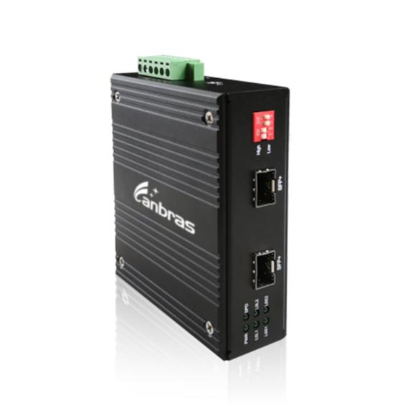

Introduction

Industrial 10G OEO Converter is a connection between fiber to fiber 10Gbps equipment function as fiber media converter, or as fiber repeater for long distance transmission in harsh environment at operating temperature -40~ 75℃.

It is for network backbone (SAN, LAN, MAN) application. Support SDH/SONET STM-64/OC-192, 10G fiber channel, 10G Ethernet, which can be applied in R&D laboratory, data center, telecommunication room. It supports optical wavelength conversion 1310nm/1550nm/CWDM/DWDM with Loop-back.

Features

- Transparent Transport and very low delay
- 3R function (Regeneration, Reshaping, Re-timing)
- Support hot plugging, full state led display, easy installation
- Support ITUT prescribed DWDM/CWDM wavelength, and can also display it's DDM function
- Support Loop-back and Jumbo Frame

DIP Switch

DIP-Bit Number | Switch Status | Function Descriptions
1 | ON | 1.25~8.5G
 | OFF | 10.3G or 14.025G
2 | ON | Reserved
 | OFF | Reserved
3 | ON | Reserved
 | OFF | Reserved
4 | ON | Reserved
 | OFF | Reserved

Specifications

Transmission Speed
8.5Gb/s-11.7Gb/s
Interface Type
Type A : XFP to XFP
Type B : XFP to SFP+
Type C : SFP+ to XFP
Type D: SFP+ to SFP+
Protocols
8.5G Fiber Channel
SONET OC-192, SDH STM-64 (9.95Gbps)
10G WAN (10Gbps)
10G LAN (10.31Gbps)
OTN OTU-2 (G.709) (10.70Gbps)
10G LAN with 255/237 FEC coding (11.09Gbps)
10G Fiber Channel (11.32Gbps)
10G POS

Power Requirement
Standalone: DC12V~48V
Power consumption: ≤4W

Work Environment
Operating Temp: -40~ 75℃
Storage Temp: -40~ 85℃
Humidity: 5%~90% (non-condensing)

Dimension
Standalone: 110(L)*96.5(W)*35(H)mm

Transmission Distance
XFP module: Up to 80Km
SFP+ module: up to 80km

Maximum Packet Forwarding Rate
14,880,950/S

LED Instructions
PWR, SPD, LOS1, LOL2,LOS2, LOL2

Product Size (mm)

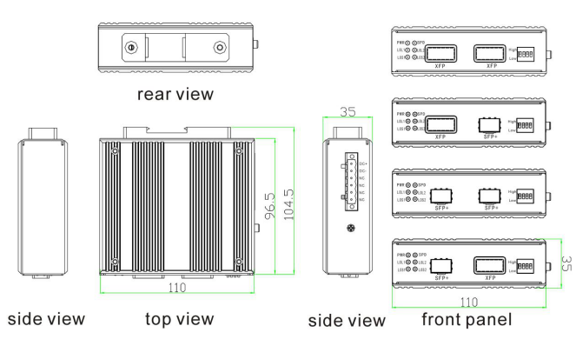

Ordering Information

PART NO | DESCRIPTION
LA-10GOEO-I | Industrial 10G OEO Converter, 8.5Gb/s-11.7Gb/s  Operating Temperature -40~ 75℃

