LA-SW-FG0224P

48V Standard POE: IEEE802.3af/at

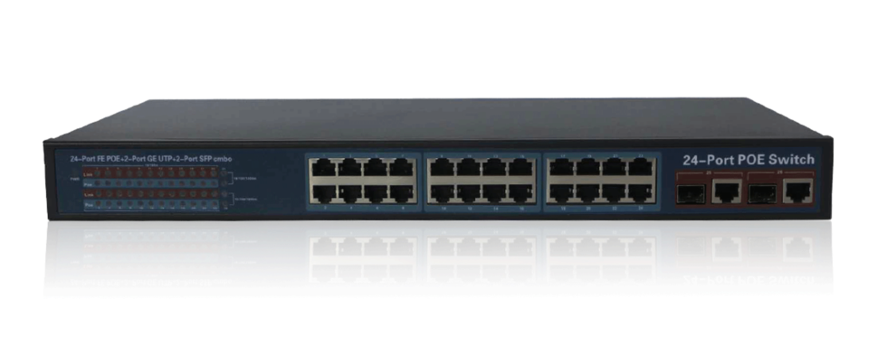

Features

- Can supply power to wireless AP and IP Camera
- 24*10/100Mbps auto-sensing RJ45 ports, 2*gigabit combo TP/SFP ports
- Total PoE power: 250W (Port 1 to Port 24)
- Maximum power per port ups to 30W
- Support Auto MDI/ MDIX
- Support anti-thunder to port(AC power port: Differential mode + / -2kv, common mode + / -4kv)
- IEEE802.3 10Base-T, IEEE802.3u 100Base-TX, IEEE802.3z, IEEE802.3ab
- Flow control mode: full duplex adopts IEEE 802.3x standard, and half duplex adopts Back pressure standard
- Adopt store-and-forward architecture. Up to line speed at the frame length range of 64 to 1536
- Built-in 1U rack power supply series, easy to place it into standard mounting brackets
- Plug and play
This KP-P1024N switch provides a network point for power supply and data transmission. All the 24 PoE ports can be connected with 10/100Mps quickly, and the uplink port is 1.25Gbps fiber interface, among which 1-24 ports can provide standard IEEE 802.3af/at power supply. Due the advanced self-sensing algorithm supply power for IEEE802.3af/at terminal unit only, there is no need to worry about damaging proprietary PoE or non-PoE standard equipment. In addition, it will stop power supply when PoE devices are not connected. In short, The KP-P1024N features simple and reliable design, automatic identification PoE requirements, duplex and high-speed.

Target Industries

- HD monitor transmission and power supply
- Wireless AP layout transmission and power supply
- Network telephone transmission , intelligent house and home system
- Intelligent transportation supervisory system(ITS)
- High-speed Way supervisory/Tele-Communication System
- Security protection system, TV medical treatment
- Long-distance Muti-media Schooling, Campus monitoring
- Long-distance broadcast television transmission system
- High-building Security Protection, Military Tele-Com projects
Specifications

Product Name | 28-Port PoE switch with 2 Gigabit TP/SFP Combo Ports
Model | LA-SW-FG0224P
Type | 24x 10/100M copper cable RJ45 ports(all ports support MDI/MDIX) ,2x gigabit combo ports
Network Media | 10BASE-T: Cat3,4,5 UTP(≤100 meter) 100BASE-TX: 5 classes and more than 5 classes(≤100 meter)
Bandwidth | 14.8Gbps (non-blocking)
Address | 16K
MTBF | 100,000 hours
Network Latency | Maximum delay less than 20 microseconds
Forwarding Mode | Store-And-Forward
Buffer Memory | 4M
Network | IEEE 802.3i 10BASET IEEE 802.3u 100BASETX IEEE 802.3x Flow Control IEEE 802.3af/at DTE Power via
LED Display | System: power supply Every Port: connecting, PoE working status
PoE Ports | 24 * PoE Ports
PoE Port Power | Max 30W
PoE Standard | IEEE802.3af/at
Working Environment | Operating Temperature: -20 ° ~ 55 ° C Storage Temperature: -20 ° ~ 75 ° C Humidity: 10% ~ 90%, non-condensing Storage Humidity: 10% ~ 95%, non-condensing Working Altitude: 3000 m (10,000 ft)  Storage Altitude: 3,000 m (10,000 ft)
Certification | CE Mark ,commercial CE/LVD EN60950
Radiation | CE mark, commercial FCC Part 15 Class B VCCI Class B EN 55022 (CISPR 22), Class B
Transmission Distance | Single mode(9/125um) optical transmission, transmission distance: 25km(double optical default, single  optical alternative)
Product Size | 430mm * 200mm * 44mm
Warranty | 3 year

Ordering Information Million HD surveillance transmission and power supply
◆ Wireless AP distribution transmission and power supply
◆ VoIP transmission, intelligent home systems
◆ City intelligent traffic monitoring system (ITS), safe city, and wireless city
◆ Highway surveillance system, electronic road surveillance, snapshot system
◆ large industrial factory& enterprise security surveillance system, network multifunction system
◆ Remote multimedia teaching & campus surveillance, video conferencing systems
◆ Building intercom, wireless communications, video surveillance

Product Model
LA-SW-FG0224P
Product Description
24x 10/100M Ethernet PoE ports + 2x gigabit combo ports PoE switch, and 1-24 ports supports IEEE802.3af/at, total power is 250W
Ordering Notes
PoE default power supply is end-span (1/2, 3/6 line pair), alternative PoE
Power supply is mid-span (4/5,7/8 line pair)

