LA-IS8M-G1216

12*1000 Base-X, 16*10/100/1000 Base-T Managed Industrial Switch (PoE Optional)

Highlight Information
LA-XXX/LAM-XXX Series

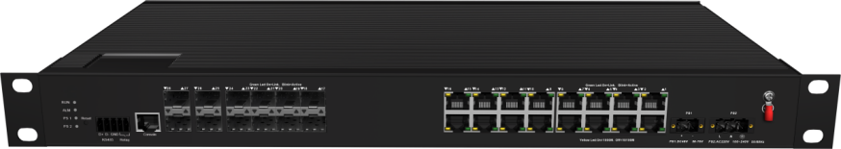

For LA-XXX Series

For LA-XXX Series

Introduction

This LA-IS8M-G1216, management industrial Ethernet fast switch, PoE is optional, providing excellent industrial quality such as high/low temperature resistance, lightning protection, etc., through the design of fanless cooling circuit, wide range working environment temperature, high protection grade and other technologies. Besides, various rich protocols, such as integrated switching and security, support public Ethernet multi-ring protection technology (ERPS), greatly improve network flexibility and enhance the reliability and security of industrial networks.

It can also meet the deployment requirements of rail transit, safe city, intelligent transportation, outdoor monitoring and other harsh environments.

Features

Input Voltage: DC：36~75V/AC：100~240V 50/60Hz Operating Temperature: -40℃ ~ +75℃
Shell: IP40 protection, fanless design Test Report: CCC, RoHS, FC, CE
Anti-static: 8KV-15KV MTBF: 100000 Hours

Specifications

PART NO | LA-IS8M-G1216
Provider Mode Ports
Fixed Port | 12*1000 Base-X, 16*10/100/1000 Base-T
Management Port | Support console
Power Interface | Phoenix terminal, dual power supply redundancy
LED Indicators | PWR, Link/ACT LED
Cable Type & Transmission Distance
Twisted-pair | 0-100m（CAT5e,CAT6）
Monomode Optical Fiber | 20/40/60/80/100KM
Multimode Optical Fiber | 550m
Network Topology
Ring Topology | Support
Star Topology | Support
Bus Topology | Support
Tree Topology | Support
Hybrid Topology | Support
Electrical Specifications
Input Voltage | DC36-75V/AC 100-240V 50-60HZ
Total Power Consumption | Non POE <36W，with POE<276W
PoE Support
PoE Port | 1-16
PoE Protocol | 802.3af，802.3at
Pin Assignment | 1,2,3,6
PoE Management | Support
Layer 2 Switching
Switching Capacity | 160G
Packet Forwarding Rate | 95.23Mpps
MAC Address Table | 16K
VLAN | Support 4K
Buffer | 12M
Forwarding Delay | <10us
MDX/MIDX | Support
Flow Control | Support
Jumbo Frame | 10Kbytes
Spanning Tree | Support STP/RSTP/MSTP
Ring Protocol | Support ERPS
Link Aggregation | Support 12 group
Multicast | Support IGMP Snooping
Port Mirroring | Support
Storm Control | Support
Interface Counters | Support
QINQ | Support
802.1X | Support
Radius/Mac Authentication | Support
Layer 3 Route
Static Route | Support 256 static route
Convergence
ACL | Support ACL 500  Support IP standard ACL  Support MAC expand ACL  Support IP expand ACL
QOS | Support QoS re-marking, priority mapping  Support SP, WRR queue scheduling  Support engress rate-limited, egress rate-limit  Support Policy-based QoS
Management
CLI | Support
Console | Support
Telnet | Support
WEB Management | Support
SNMP | Support SNMPv1/v2c
User Management | Support
System Log | Support
Configuration File Download/Upload | Support
Upgrade Firmware | Support
Environment
Operating Temperature | -40℃~+75℃
Storage Temperature | -40℃~+75℃
Relative Humidity | 5%~95% （non-condensing）
Thermal Methods | Fanless, natural cooling
MTBF | 100,000 hours
Mechanical Dimensions
Product Size | 440*245*44mm (W×H×D)
Installation Method | Rack mounted
Weight | 3.6KG around
EMC & Ingress Protection
IP Level | IP40
Surge Protection of Power | IEC 61000-4-5 Level 3 (4KV/2KV）（8/20us)
Surge Protection of Ethernet Port | IEC 61000-4-5 Level 3 (4KV/2KV）（10/700us)
RS | IEC 61000-4-3 Level 3 （10V/m）
EFI | IEC 61000-4-4 Level 3 （1V/2V）
CS | IEC 61000-4-6 Level 3 （10V/m）
PFMF | IEC 61000-4-8 Level4（30A/m）
DIP | IEC 61000-4-11 Level3 （10V）
EMI | CLASS A
ESD | IEC 61000-4-2 Level 4 （8K/15K）
Free Fall | 0.5m
Authentication
Authentication | CCC/CE/FCC/RoHS

Dimensions

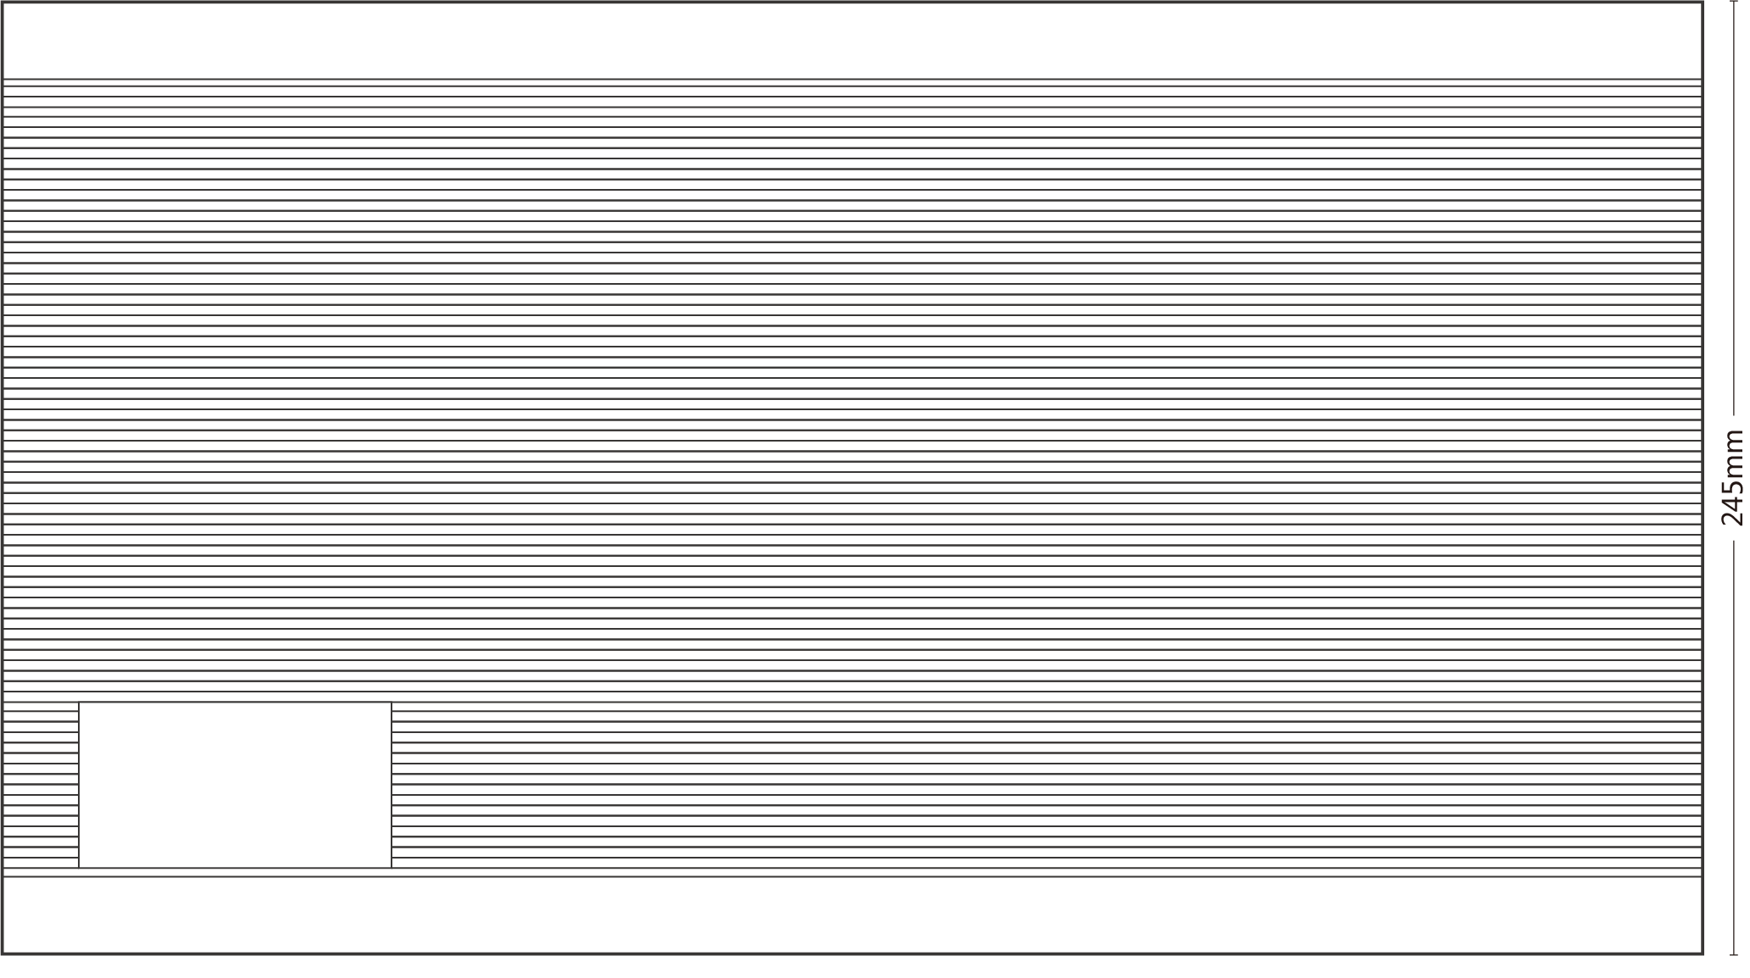

Rear view

Front view

Ordering Information

PART NO | DESCRIPTION
LA-IS8M-G1216 | 12*1000 Base-X, 16*10/100/1000 Base-T  DC power supply

Accessories

PART NO | DESCRIPTION
LA-IS8M-G1216 | equipment, terminals, power adapter(optional),  instructions, product certification

