LA-IS7M2-G0808

# 8*1000Base-X, 8*10/100/1000Base-T Managed Industrial Ethernet Switch (PoE Optional)

***Highlight Information***

LA-XXX/LAM-XXX Series

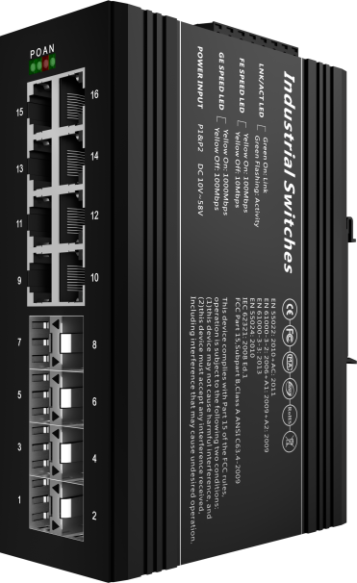

For LA-XXX Series

For LA-XXX Series



**Introduction**

This device is 8 Gigabit & 8 10/100/1000 Base-T managed industrial Ethernet fast switch, providing high resistance through fanless cooling circuit design, wide range of working environment temperature, high protection level and other technologies. /Excellent industrial quality such as low temperature and lightning protection; and integrated protocols such as exchange and security, and support for public Ethernet multi-ring protection technology (ERPS), which greatly enhances network flexibility and enhances industrial networks. Reliability and security.

It can better meet the deployment requirements of rail transit, safe city, intelligent transportation, outdoor monitoring and other harsh environments.

**Features**

**Input Voltage:** DC12~58V **Operating Temperature:** -30℃ ~ +75℃

**Shell:** IP40 protection, fanless design **Test Report:** CCC, RoHS, FC, CE, ISO

**Anti-static:** 8KV-15KV **MTBF:** 100000 Hours

**Specifications**

|  |  |
| --- | --- |
| PART NO | LA-IS7M2-G0808 |
| Provider Mode Ports | |
| Fixed Port | 8*1000 Base-X, 8*10/100/1000 Base-T |
| Management Port | Phoenix terminal, RS232 (Console) |
| Power Interface | Phoenix terminal, DC dual power supply and AC single power supply three power supply redundancy |
| LED Indicators | PWR, Link/ACT LED, NMC, ALM |
| Dialing Instructions | |
| 1 C/D | Console/data selection |
| 2 LGY | Standard/non-standard PoE selection |
| 3 VLAN | Port isolation |
| 4 RST | Reset |
| Cable Type & Transmission Distance | |
| Twisted-pair | 0-100m（CAT5e,CAT6） |
| Monomode Optical Fiber | 20/40/60/80/100KM |
| Multimode Optical Fiber | 550m |
| Network Topology | |
| Ring Topology | Support |
| Star Topology | Support |
| Bus Topology | Support |
| Tree Topology | Support |
| Hybrid Topology | Support |
| Electrical Specifications | |
| Input Voltage | DC 12-58V / AC 85-264V |
| Total Power Consumption | Non PoE <15W，PoE <255W(DC powered only) |
| Voltage Alarm | Support |
| PoE (Support Optional） | |
| PoE Port | 1-8 |
| PoE Protocol | 802.3af，802.3at |
| Pin Assignment | 1,2,3,6 |
| PoE Mode | Standard & non-standard support |
| PoE Management | Unsupported |
| Remote PD Reset | Support |
| Layer 2 Switching | |
| Switching Capacity | 54G |
| Packet Forwarding Rate | 23.8 Mpps |
| MAC Address Table | 8K |
| VLAN | Support 4K |
| Buffer | 8M |
| Forwarding Delay | <10us |
| MDX/MIDX | Support |
| Flow Control | Support |
| Jumbo Frame | 9.6Kbytes |
| Spanning Tree | Support STP/RSTP/MSTP |
| Ring Protocol | Support ERPS |
| Link Aggregation | Support 8 group |
| Linear Protection Of Ethernet | Support ELPS |
| Port Isolation | Support |
| Management | |
| CLI | Support |
| Management IP | Support static IPV4, DHCP IPV4 |
| Console | Support |
| Telnet | Support |
| WEB | Support |
| SNMP | Support SNMPv1/v2c/v3 |
| User Management | Support |
| System Log | Support |
| Configuration File Download/Upload | Support |
| Upgrade Firmware | Support |
| Environment | |
| Operating Temperature | -35℃~+70℃ |
| Storage Temperature | -35℃~+85℃ |
| Relative Humidity | 5%~95% （non-condensing） |
| Thermal Methods | Fanless, natural cooling |
| MTBF | 100,000 hours |
| Mechanical Dimensions | |
| Product Size | 143X104X48mm (W×H×D) |
| Installation Method | DIN-rail |
| Weight | 0.7KG around |
| EMC & Ingress Protection | |
| IP Level | IP40 |
| Surge Protection of Power | IEC 61000-4-5 Level 3 (4KV/2KV）（8/20us) |
| Surge Protection of Ethernet Port | IEC 61000-4-5 Level 3 (4KV/2KV）（10/700us) |
| ESD | IEC 61000-4-2 Level 4（8K/15K） |
| Authentication | |
| Authentication | CCC/CE/FCC/RoHS |

**Dimensions**

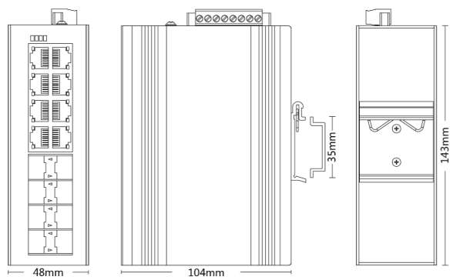

Front view Side view Back view

**Terminal Definition**



|  |  |  |  |  |  |  |  |  |
| --- | --- | --- | --- | --- | --- | --- | --- | --- |
| Relay | | Console | | PWR1/PWR2（DC） | | PWR3（AC） | |  |
| F1 | Relay pin | GND | Ground | P1+ | P1 positive electrode | L | Fire line |
| F2 | Relay pin | RX2 | Receive data | P1/P2- | P1/P2 negative electrode | N | Neutral line |
|  | | TX2 | Send data | P2+ | P2 positive electrode |  | | Ground terminal |

**Ordering Information**

|  |  |
| --- | --- |
| PART NO | DESCRIPTION |
| LA-IS7M2-G0808 | 8*1000Mbps SFP Port, 8*10/100/1000M RJ45 Port (PoE is optional) |

**Accessories**

|  |  |
| --- | --- |
| PART NO | DESCRIPTION |
| LA-IS7M2-G0808 | device, terminals, specification, certificate  adapter(optional) |