LA-IS7M2-G0424

4*1000Base-X, 24*10/100/1000Base-T Managed Industrial Ethernet Switch (PoE Optional)

Highlight Information
LA-XXX/LAM-XXX Series

For LA-XXX Series

For LA-XXX Series

Introduction

This device is equipped with 4 1000Base-X & 24 10/100/1000Base-T Ethernet port-managed industrial Ethernet fast switch. It is designed with fanless cooling circuit design, wide operating temperature range and high protection level. Excellent industrial grade quality such as high/low temperature and lightning protection; and integrated protocols such as exchange and security, and support for public Ethernet multi-ring protection technology (ERPS), which greatly enhances network flexibility and enhances industry. Network reliability and security.

It can better meet the deployment requirements of rail transit, safe city, intelligent transportation, outdoor monitoring and other harsh environments.

Features

Input Voltage: DC12~58V Operating Temperature: -40℃ ~ +75℃
Shell: IP40 protection, fanless design Test Report: CCC, RoHS, FC, CE, ISO
Anti-static: 8KV-15KV MTBF: 100000 Hours

Specifications

PART NO | LA-IS7M2-G0424
Provider Mode Ports
Fixed Port | 4*1000 Base-X, 24*10/100/1000 Base-T
Management Port | Support console
Power Interface | Phoenix terminal, redundant dual
LED Indicators | PWR, Link/ACT LED
Cable Type & Transmission Distance
Twisted-pair | 0-100m（CAT5e,CAT6）
Monomode Optical Fiber | 20/40/60/80/100KM
Multimode Optical Fiber | 550m
Network Topology
Ring Topology | Support
Star Topology | Support
Bus Topology | Support
Tree Topology | Support
Hybrid Topology | Support
Electrical Specifications
Input Voltage | DC12-58V
Total Power Consumption | PoE <26W
Layer 2 Switching
Switching Capacity | 68G
Packet Forwarding Rate | 50.59Mpps
MAC Address Table | 16K
VLAN | Support 4K
Buffer | 12M
Forwarding Delay | <10us
MDX/MIDX | Support
Flow Control | Support
Jumbo Frame | 10Kbytes
Spanning Tree | Support STP/RSTP/MSTP
Ring Protocol | Support ERPS
Link Aggregation | Support 12 group
Multicast | Support IGMP Snooping
Port Mirroring | Support
Storm Control | Support
Interface Counters | Support
QINQ | Support
802.1X | Support
Radius/Mac Certification | Support
Port Isolation | Support
Rmon | Support
NTP Client | Support
DHCP Client | Support
DHCP Snooping | Support
Ping/Tracert Detection | Support
Dying Gasp | Support
Optical Module DDM | Support
Convergence
ACL | Support ACL 500  Support IP standard ACL  Support MAC expand ACL  Support IP expand ACL
QOS | Support QoS re-marking, priority mapping  Support SP, WRR queue scheduling  Support engress rate-limited, egress rate-limit  Support Policy-based QoS
Management
CLI | Support
Console | Support
Telnet | Support
WEB Management | Support
SNMP | Support SNMPv1/v2c/v3
User Management | Support
System Log | Support
Configuration File Download/Upload | Support
Upgrade Firmware | Support
Environment
Operating Temperature | -40℃~+75℃
Storage Temperature | -40℃~+85℃
Relative Humidity | 5%~95% （non-condensing）
Thermal Methods | Fanless, natural cooling
MTBF | 100,000 hours
Mechanical Dimensions
Product Size | 108*104*143mm (W×H×D)
Installation Method | DIN-rail
Weight | 1.3KG around
EMC & Ingress Protection
IP Level | IP40
Surge Protection of Power | IEC 61000-4-5 Level 3 (4KV/2KV）（8/20us)
Surge Protection of Ethernet Port | IEC 61000-4-5 Level 3 (4KV/2KV）（10/700us)
RS | IEC 61000-4-3 Level 3 （10V/m）
EFI | IEC 61000-4-4 Level 3 （1V/2V）
CS | IEC 61000-4-6 Level 3 （10V/m）
PFMF | IEC 61000-4-8 Level4（30A/m）
DIP | IEC 61000-4-11 Level3 （10V）
ESD | IEC 61000-4-2 Level 4 （8K/15K）
Free Fall | 0.5m
Authentication
Authentication | CCC/CE/FCC/RoHS

Dimensions

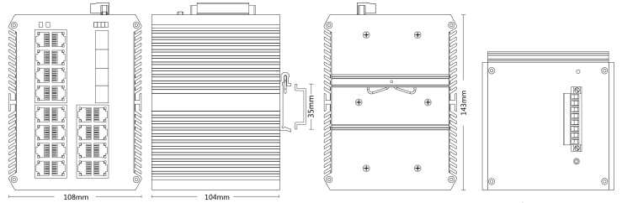

Front view Side view Back view Top view

Ordering Information

PART NO | DESCRIPTION
LA-IS7M2-G0424 | 4*1000Mbps SFP Port, 24*10/100/1000M RJ45 Port (PoE is optional)

Accessories

PART NO | DESCRIPTION
LA-IS7M2-G0424 | device, terminals, specification, certificate  adapter(optional)

