LA-IS7M2-G0101

1*1000Base-X, 1*10/100/1000Base-T Managed Industrial Ethernet Switch (PoE Optional)

Highlight Information
LA-XXX/LAM-XXX Series
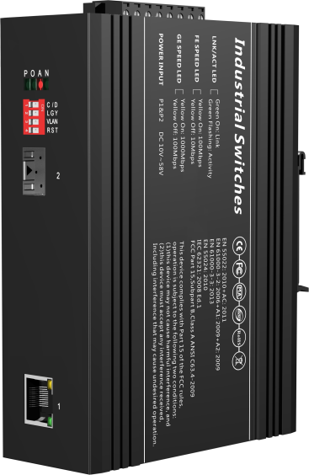

For LA-XXX Series

For LA-XXX Series

Introduction

This device is a Gigabit light & 1 10/100/1000 Base-T managed industrial Ethernet fast switch, providing high resistance by fanless cooling circuit design, wide range of working environment temperature, high protection level and other technologies. Excellent industrial quality such as low temperature and lightning protection; and a variety of rich protocols such as integrated switching and security, which enhance the reliability and safety of industrial networks.

It can better meet the deployment requirements of rail transit, safe city, intelligent transportation, outdoor monitoring and other harsh environments.

Features

Input Voltage: DC12~58V Operating Temperature: -40℃ ~ +75℃
Shell: IP40 protection, fanless design Test Report: CCC, RoHS, FC, CE, ISO
Anti-static: 8KV-15KV MTBF: 100000 Hours

Specifications

PART NO | LA-IS7M2-G0101
Provider Mode Ports
Fixed Port | 1*1000 Base-X, 1*10/100/1000 Base-T
Management Port | Support console
Power Interface | Phoenix terminal, redundant dual
LED Indicators | PWR, Link/ACT LED
Reset | Dial reset
Dialing Instructions
1 C/D | Reserved
2 LGY | Standard/non-standard PoE selection
3 VLAN | Reserved
4 RST | Reset & restore factory
Cable Type & Transmission Distance
Twisted-pair | 0-100m（CAT5e,CAT6）
Monomode Optical Fiber | 20/40/60/80/100KM
Multimode Optical Fiber | 550m
Network Topology
Ring Topology | Unsupported
Star Topology | Support
Bus Topology | Support
Tree Topology | Support
Hybrid Topology | Support
Electrical Specifications
Input Voltage | DC12-58V
Total Power Consumption | <6W
Voltage Alarm | Support
PoE (Support Optional）
PoE Port | 1-4
PoE Protocol | 802.3af，802.3at
Pin Assignment | 1,2,3,6
PoE Management | Support
Layer 2 Switching
Switching Capacity | 14G
Packet Forwarding Rate | 10.416Mpps
MAC Address Table | 8K
VLAN | Support 64K
Buffer | 1M
Forwarding Delay | <5us
MDX/MIDX | Support
Flow Control | Support
Jumbo Frame | 10Kbytes
Interface Counters | Support
WatchDog | Support
LFP | Support
Management
Console | Support
Telnet | Unsupported
WEB | Support
SNMP | Support
SSH | Unsupported
Environment
Operating Temperature | -40℃~+75℃
Storage Temperature | -40℃~+75℃
Relative Humidity | 5%~95% （non-condensing）
Thermal Methods | Fanless, natural cooling
MTBF | 100,000 hours
Mechanical Dimensions
Product Size | 143X104X48mm (W×H×D)
Installation Method | DIN-rail
Weight | 0.6KG around
EMC & Ingress Protection
IP Level | IP40
Surge Protection of Power | IEC 61000-4-5 Level 3 (4KV/2KV）（8/20us)
Surge Protection of Ethernet Port | IEC 61000-4-5 Level 3 (4KV/2KV）（10/700us)
RS | IEC 61000-4-3 Level 3 （10V/m）
EFI | IEC 61000-4-4 Level 3 （1V/2V）
CS | IEC 61000-4-6 Level 3 （10V/m）
PFMF | IEC 61000-4-8 Level4（30A/m）
DIP | IEC 61000-4-11 Level3 （10V）
ESD | IEC 61000-4-2 Level 4 （8K/15K）
Free Fall | 0.5m
Authentication
Authentication | CCC/CE/FCC/RoHS

Dimensions

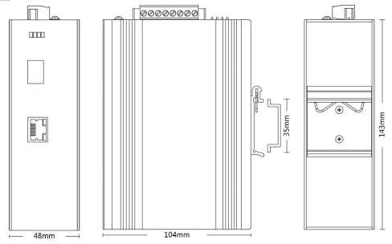

Front view Side view Back view

Ordering Information

PART NO | DESCRIPTION
LA-IS7M2-G0101 | 1*1000Mbps SFP Port, 1*10/100/1000M RJ45 Port
LA-IS7M2-G0101-SC | 1*1000Mbps SC Port, 1*10/100/1000M RJ45 Port
LA-IS7M2-G0101-FC | 1*1000Mbps FC Port, 1*10/100/1000M RJ45 Port
LA-IS7M2-G0101-ST | 1*1000Mbps ST Port, 1*10/100/1000M RJ45 Port

Accessories

PART NO | DESCRIPTION
LA-IS7M2-G0101 | device, terminals, specification, certificate  adapter(optional)

