LA-IS6N-G0101

1*1000Base-X, 1*10/100/1000Base-T Industrial Ethernet Switch (PoE Optional)

Highlight Information
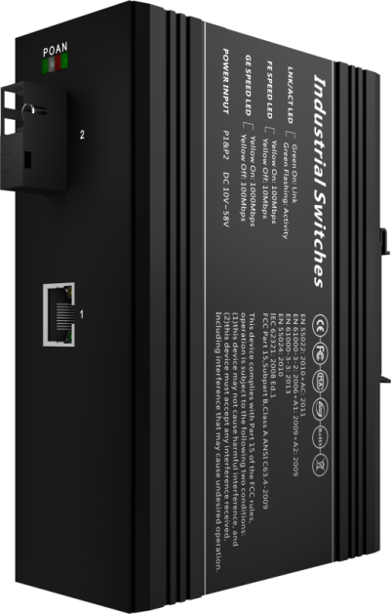
LA-XXX/LAM-XXX Series

For LA-XXX Series

For LA-XXX Series

Introduction

This device is 1*1000Base-X & 1*10/100/1000Base-T Industrial Ethernet Switch, PoE is optional. Through the fanless heat dissipation circuit design, wide range of working environment temperature, high protection level and other technologies, it provides excellent industrial quality with high/low temperature resistance and lightning protection, and enhances the reliability and safety of industrial networks.

It can better meet the deployment requirements of rail transit, safe city, intelligent transportation, outdoor monitoring and other harsh environments.

Features

Input Voltage: DC12~58V Operating Temperature: -40℃ ~ +75℃
Shell: IP40 protection, fanless design Test Report: CCC, RoHS, FCC, CE
Anti-static: 8KV-15KV MTBF: 100000 Hours

Specifications

PART NO | LA-IS6N-G0101
Provider Mode Ports
Fixed Port | 1*1000 Base-X SFP, 1*10/100/1000Base-T PoE
Power Interface | Phoenix terminal, redundant dual power supply
LED Indicators | PWR，OPT ,NMC，ALM
DIP Switch
1 C/D | Remote PD Reset
2 LGY | Stand/Non-standard PoE Mode
3 VLAN | /
4 RST | Reset
Cable Type & Transmission Distance
Twisted-pair | 0-100m（CAT5e,CAT6）
Monomode Optical Fiber | 20/40/60/80/100KM
Multimode Optical Fiber | 550m
Network Topology
Ring Topology | Unsupported
Star Topology | Support
Bus Topology | Support
Tree Topology | Support
Hybrid Topology | Support
Electrical Specifications
Input Voltage | DC12-58V
Total Power Consumption | <6W
Voltage Alarm | Support
Layer 2 Switching
Switching Capacity | 14G
Packet Forwarding Rate | 10.416Mpps
MAC Address Table | 8K
VLAN | Unsupported
Buffer | 1M
Forwarding Delay | <5us
MDX/MIDX | Support
Flow Control | Support
Jumbo Frame | 10K bytes
Watch Dog | Support
Port Isolation | Support
Environment
Operating Temperature | -40℃~+75℃  The device is tested for 4 hours at temperatures in 85℃
Storage Temperature | -40℃~85℃
Relative Humidity | 5%~95% （non-condensing）
Thermal Methods | Fanless, natural cooling
MTBF | 100,000 hours
Mechanical Dimensions
Product Size | 143X104X48mm (W×H×D)
Installation Method | DIN-rail
Weight | 0.6KG around
EMC & Ingress Protection
IP Level | IP40
Surge Protection of Power | IEC 61000-4-5 Level 3 (4KV/2KV）（8/20us)
Surge Protection of Ethernet Port | IEC 61000-4-5 Level 3 (4KV/2KV）（10/700us)
RS | IEC 61000-4-3 Level 3（10V/m）
EFI | IEC 61000-4-4 Level 3（1V/2V）
CS | IEC 61000-4-6 Level 3（10V/m）
PFMF | IEC 61000-4-8 Level 4（30A/m）
DIP | IEC 61000-4-11 Level 3 （10V）
ESD | IEC 61000-4-2 Level 4（8K/15K）
Free Fall | 0.5m
Authentication
Authentication | CCC/CE/FCC/RoHS

Dimensions

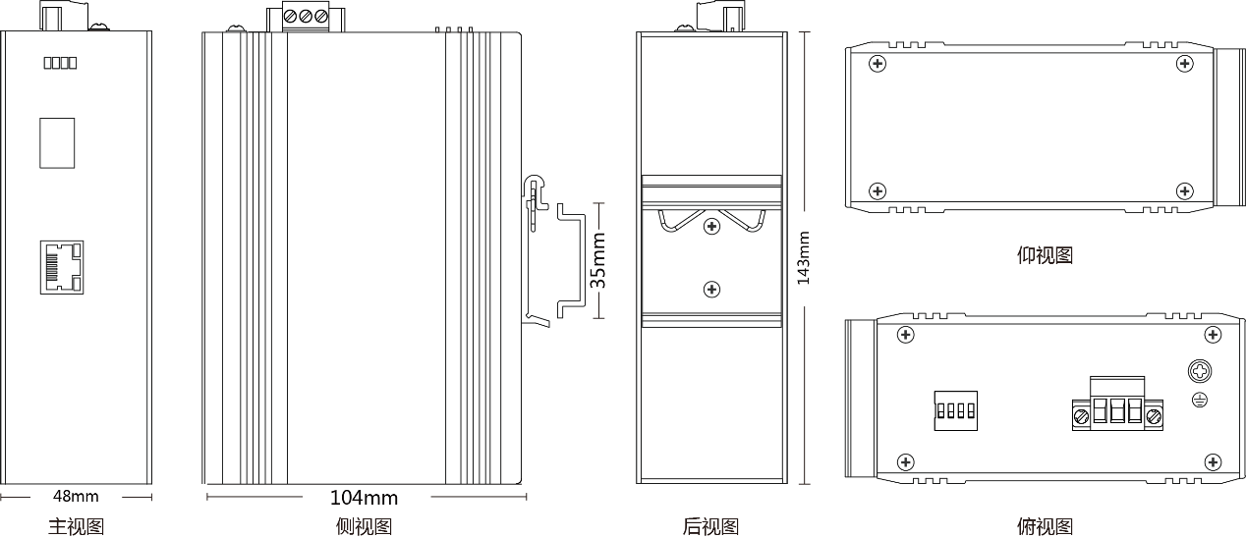

Bottom View

Front view Side view Back view Top view

Ordering Information

PART NO | DESCRIPTION
LA-IS6N-G0101 | 1*1000Mbps SFP Port, 1*10/100/1000Mbps RJ45 Port
LA-IS6N-G0101-SC | 1*1000Mbps SC Port, 1*10/100/1000Mbps RJ45 Port, PoE 802.3af & at
LA-IS6N-G0101-FC | 1*1000Mbps FC Port, 1*10/100/1000Mbps RJ45 Port, PoE 802.3af & at
LA-IS6N-G0101-ST | 1*1000Mbps ST Port, 1*10/100/1000Mbps RJ45 Port, PoE 802.3af & at

Accessories

PART NO | DESCRIPTION
LA-IS6N-G0101 | device, terminals, specification, certificate  adapter(optional)

