LA-IS4N-G0104

1*1000Base-X, 4*10/100/1000Base-T Industrial Ethernet Switch (PoE Optional)

Highlight Information
LA-XXX/LAM-XXX Series
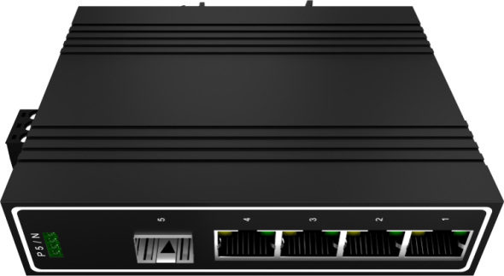

For LA-XXX Series

For LA-XXX Series

Introduction

This device 1*1000Base-X, 4*10/100/1000Base-T Industrial Ethernet Switch, PoE is optional. Through the fanless heat dissipation circuit design, wide range of working environment temperature, high protection level and other technologies, it provides excellent industrial quality with high/low temperature resistance and lightning protection, and enhances the reliability and safety of industrial networks.

The device can be widely applied to various broadband data transmission fields such as intelligent transportation, telecommunications, security, financial securities, customs, shipping, power, water conservancy and oil fields.

Features

Input Voltage: DC12~58V Operating Temperature: -30℃ ~ +75℃
Shell: IP40 protection, fanless design Test Report: CCC, RoHS, FCC, CE
Anti-static: 8KV-15KV MTBF: 100000 Hours

Specifications

PART NO | LA-IS4N-G0104
Provider Mode Ports
Fixed Port | 1*1000Base-X, 4*10/100/1000Base-T
Power Interface | Phoenix terminal, dual power supply
LED Indicators | PWR, mainboard light, NMC, expansion board light
DIP Switch
1 LFP | Remote PD Reset
2 LGY | LEGACY (Standard & Non-standard PoE)
3 VLAN | Port Isolation
4 RST | Reset
Cable Type & Transmission Distance
Twisted-pair | 0-100m（CAT5e,CAT6）
Monomode Optical Fiber | 20/40/60/80/100KM
Multimode Optical Fiber | 550m
Network Topology
Ring Topology | Unsupported
Star Topology | Support
Bus Topology | Support
Tree Topology | Support
Hybrid Topology | Support
Electrical Specifications
Input Voltage | DC12-58V
Total Power Consumption | Non PoE<5W ;PoE<125W
PoE Model | Support standard / non-standard POE
Layer 2 Switching
Switching Capacity | 14G
Packet Forwarding Rate | 10.416Mpps
MAC Address Table | 8K
Buffer | 1M
Forwarding Delay | <5us
MDX/MIDX | Support
Flow Control | Support
Jumbo Frame | 10K bytes
Port Isolation | Support
RPR | Support
Reset | Supported
Environment
Operating Temperature | -30℃~75℃
Storage Temperature | -30℃~75℃
Relative Humidity | 10%~90% （non-condensing）
Thermal Methods | Fanless, natural cooling
MTBF | 100,000 hours
Mechanical Dimensions
Product Size | 118*81*31mm (W×H×D)
Installation Method | DIN-rail
Weight | 0.4KG around
EMC & Ingress Protection
IP Level | IP40
Surge Protection of Power | IEC 61000-4-5 Level 3 (4KV/2KV）（8/20us)
Surge Protection of Ethernet Port | IEC 61000-4-5 Level 3 (4KV/2KV）（10/700us)
ESD | IEC 61000-4-2 Level 4（8K/15K）
Authentication
Authentication | CCC/CE/FCC/RoHS

Dimensions

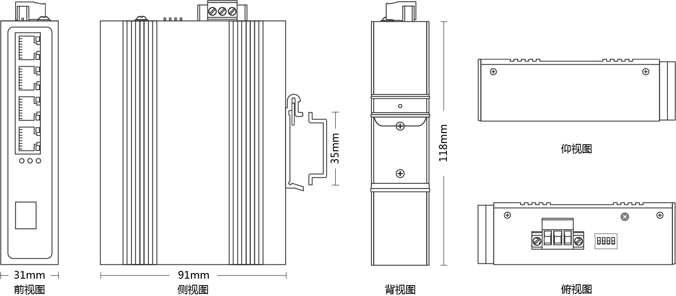

Bottom View

Front view Side view Back view Top view

Ordering Information

PART NO | DESCRIPTION
LA-IS4N-G0104 | 1*1000Base-X SFP fiber port, 4*10/100/1000M RJ45 Port, PoE support 802.3af & at
LA-IS4N-G0104-SC | 1*1000Base-X SC fiber port, 4*10/100/1000M RJ45 Port, PoE support 802.3af & at
LA-IS4N-G0104-FC | 1*1000Base-X FC fiber port, 4*10/100/1000M RJ45 Port, PoE support 802.3af & at
LA-IS4N-G0104-ST | 1*1000Base-X ST fiber port, 4*10/100/1000M RJ45 Port, PoE support 802.3af & at

Accessories

PART NO | DESCRIPTION
LA-IS4N-G0104 | device, terminals, specification, certificate  adapter(optional)

