LA-IS4N-G0008

8*10/100/1000 Base-T Unmanaged Industrial Switch (PoE Optional)

Highlight Information
LA-XXX/LAM-XXX Series

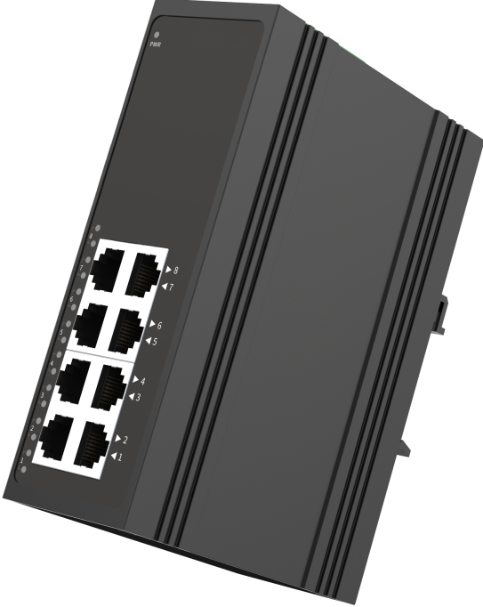

For LA-XXX Series

For LA-XXX Series

Introduction

This device 8*10/100/1000Base-T Industrial Ethernet Switch, PoE is optional. Through the fanless heat dissipation circuit design, wide range of working environment temperature -30°C~75°C, high protection level and other technologies, it provides excellent industrial quality with high/low temperature resistance and lightning protection, and enhances the reliability and safety of industrial networks.

The device can be widely applied to various broadband data transmission fields such as intelligent transportation, telecommunications, security, financial securities, customs, shipping, power, water conservancy and oil fields.

Features

Input Voltage: DC12~58V(Non-PoE)/DC48~58V(PoE) Operating Temperature: -30℃ ~ +75℃
Shell: IP40 protection, fanless design Test Report: CCC, RoHS, FCC, CE
Anti-static: 8KV-15KV MTBF: 100000 Hours

Specifications

PART NO | LA-IS4N-G0008
Provider Mode Ports
Fixed Port | 8*10/100/1000Base-T
Power Interface | Phoenix terminal, dual power supply
LED Indicators | PWR, Link/ACT LED
Cable Type & Transmission Distance
Twisted-pair | 0-100m（CAT5e,CAT6）
Monomode Optical Fiber | /
Multimode Optical Fiber | /
Network Topology
Ring Topology | Unsupported
Star Topology | Support
Bus Topology | Support
Tree Topology | Support
Electrical Specifications
Input Voltage | DC12-58V(Non-PoE)/DC48~58V(PoE)
Total Power Consumption | Non PoE<5W, with PoE<125W
Layer 2 Switching
Switching Capacity | 20G
Packet Forwarding Rate | 14.88Mpps
MAC Address Table | 16K
Buffer | 2M
Forwarding Delay | <5us
MDX/MIDX | Support
Flow Control | Support
Jumbo Frame | 10bytes
Environment
Operating Temperature | -30℃~75℃
Storage Temperature | -30℃~75℃
Relative Humidity | 5%~90% （non-condensing）
Thermal Methods | Fanless, natural cooling
MTBF | 100,000 hours
Mechanical Dimensions
Product Size | 143*104*46mm (W×H×D)
Installation Method | DIN-rail
Weight | 0.54KG around
EMC & Ingress Protection
IP Level | IP40
Surge Protection of Power | IEC 61000-4-5 Level 3 (4KV/2KV）（8/20us)
Surge Protection of Ethernet Port | IEC 61000-4-5 Level 3 (4KV/2KV）（10/700us)
ESD | IEC 61000-4-2 Level 4（8K/15K）
Authentication
Authentication | CCC/CE/FCC/RoHS

Dimensions

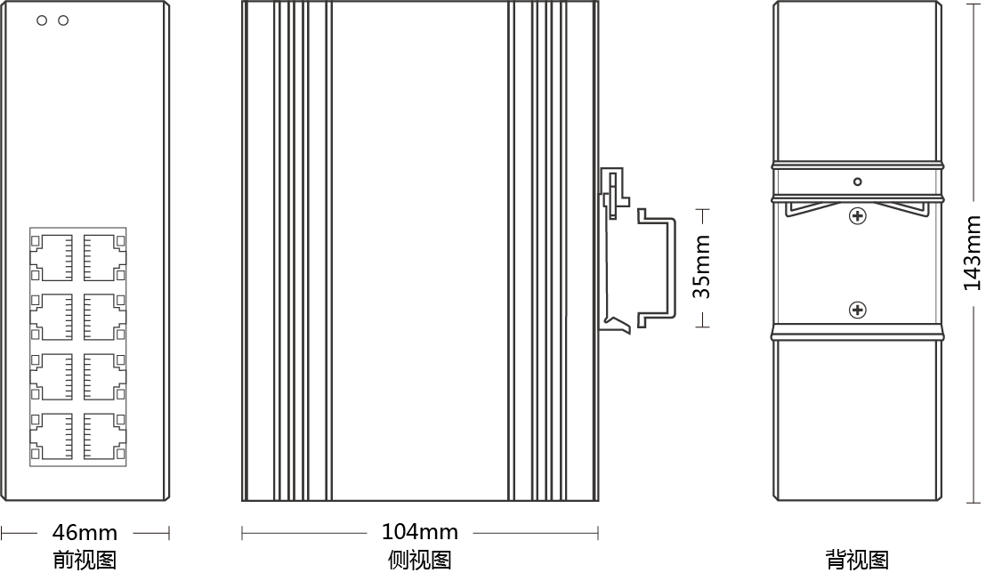

Front view Side view Back view

Ordering Information

PART NO | DESCRIPTION
LA-IS4N-G0008 | 8*10/100/1000M RJ45 Port

Accessories

PART NO | DESCRIPTION
LA-IS4N-G0008 | device, terminals, specification, certificate  adapter(optional)

